**SQL ASSIGNMENT - 9**

**1)  Write an SQL query to show the top n (say 10) records of a table.**

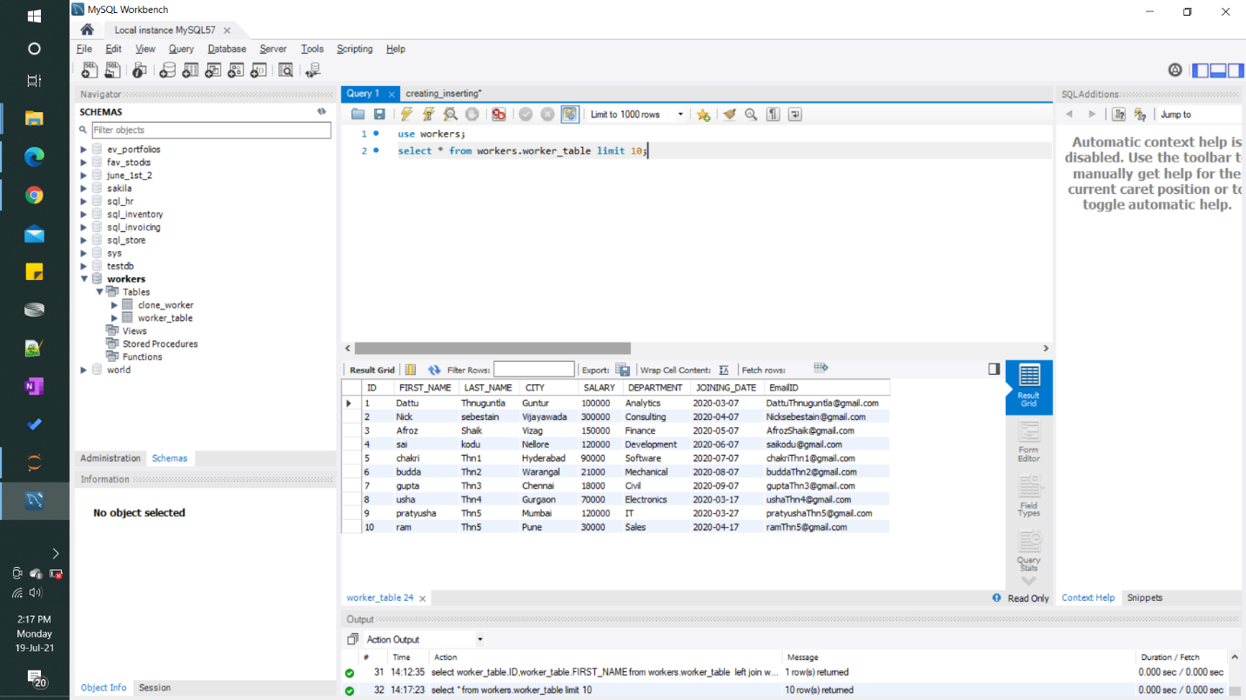

#### 2) Write an SQL query to determine the nth (say n=5) highest salary from a table.

